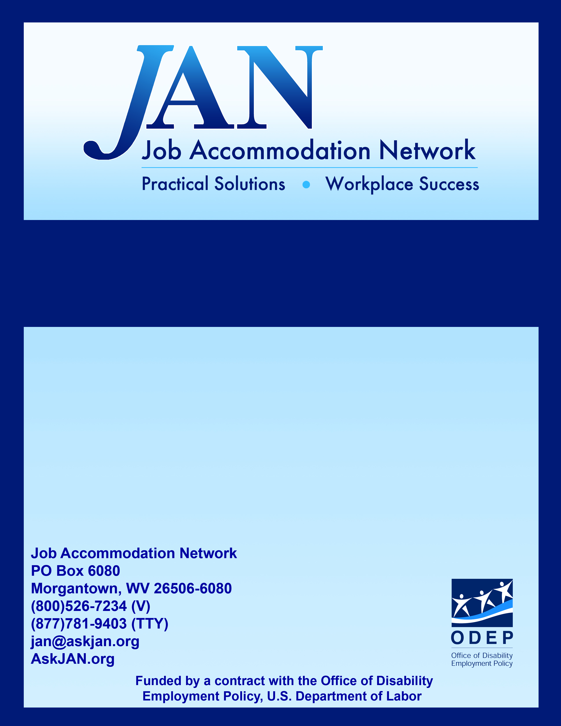
Educating the Workforce about the ADA and Accommodations

Effective Accommodation Practices (EAP) Series

JAN’S EAP SERIES

Educating the Workforce about the
ADA and Accommodations

Businesses are required to comply with a litany of federal and state employment laws. One such federal law that has a broad impact on the workforce is the ADA, as amended. Title I of the ADA prohibits disability-related discrimination in employment and requires employers to provide reasonable accommodations for qualified applicants and employees with disabilities. The impact of the ADA in employment is far reaching, affecting workers with and without disabilities, but in different ways. The law’s non-discrimination and accommodation requirements can affect all workers – from the top level C-suite, to equal opportunity (EO), human resource (HR) professionals, supervisors and managers, and all levels of personnel working for an organization.

Everyone in the workforce can benefit from having some level of knowledge about the ADA’s. Informing employees, beyond simply posting an equal opportunity poster, can benefit businesses by creating a more knowledgeable and inclusive workforce, reducing the likelihood of discrimination through awareness, and improving productivity by recognizing the value in providing reasonable accommodations. Support and a commitment from top management is critical for the success of any effort to disseminate ADA information and provide training. There must be a company-wide commitment to educate the workforce. The level of information shared and training provided will vary depending upon who is to be educated, but at the very least, all employees should have access to an organization’s reasonable accommodation policies and procedures and who to contact if they have questions or concerns.

Information about the ADA and accommodations particularly benefits professional and management staff, both in terms of ensuring that their efforts are in compliance with the ADA and that their response to workers with disabilities is appropriate given their role within the organization. For example, managers who are informed about the ADA and trained to recognize a request for accommodation are equipped to quickly proceed with the interactive process, enabling timely implementation of accommodations. Informing all employees about the ADA and encouraging a workplace culture that is inclusive of workers with disabilities is a way to ward off unnecessary questions related to the provision of reasonable accommodations, facilitate acceptance, and reduce the potential for disability-related discrimination.

Practical Ideas for Educating the Workforce
about the ADA and Accommodations

Use JAN to Educate the Workforce
Train HR Professionals, Supervisors, and Managers
Implement a Reasonable Accommodation Policy…and Tell Everyone About It!
Make a Statement!…About Reasonable Accommodation
Incorporate ADA & Accommodation Practices Into the Onboarding Process
Recognize Disability Employment Awareness Month (NDEAM)
Harness the Viral Power of Online Media

Use JAN to Educate the Workforce

Everyone has access to a professional, trusted, free service that offers technical assistance on the employment provisions of the ADA and job accommodations. JAN is that service! JAN is the leading source of free, expert, and confidential guidance on the ADA and disability employment issues, and workplace accommodations for workers in all industries and with any type of impairment. Those who can benefit from JAN’s services include private employers of all sizes, government agencies, employee representatives, and service providers, as well as people with disabilities and their family members.

Leverage the JAN service to provide training to HR professionals, supervisors and managers, and all employees about the interactive process and the requirements of the ADA and similar disability employment legislation; to provide accommodation solutions, product resources, and information referral; and to access free ADA and accommodation information through the AskJAN.org website. The AskJAN.org website is rather extensive and offers many resources that can be used in various ways to educate the entire workforce. The following resources will be useful as a start:

For Employer Representatives
- The ADA: Your Responsibilities as an Employer at http://www.eeoc.gov/facts/ada17.html
- JAN’s Employers' Practical Guide to Reasonable Accommodation under the ADA at https://AskJAN.org/publications/employers/employers-guide.cfm
- JAN’s Interactive Process at https://AskJAN.org/topics/interactive.cfm
- JAN’s How to Determine Whether a Person Has a Disability under the Americans with Disabilities Act Amendments Act (ADAAA) at https://AskJAN.org/publications/consultants-corner/vol05iss04.cfm
- JAN’s ADA Library at https://AskJAN.org/ADA-Library.cfm
- EEOC Enforcement Guidance documents at https://AskJAN.org/resources/U-S-Equal-Employment-Opportunity-Commission.cfm
- JAN’s A –Z by Disability, Topic, or Limitation at https://AskJAN.org/a-to-z.cfm
- ADA and Accommodation-related Sample Forms at https://AskJAN.org/topics/Sample-Forms.cfm
- JAN’s Training Hub at https://AskJAN.org/topics/Sample-Forms.cfm
For Workers with Disabilities
- The ADA: Your Employment Rights as an Individual With a Disability at http://www.eeoc.gov/facts/ada18.html
- Job Applicants and the ADA at http://www.eeoc.gov/facts/jobapplicant.html
- Information about Disclosure at https://AskJAN.org/topics/Disability-Disclosure.cfm
- JAN’s Employees' Practical Guide to Requesting and Negotiating Reasonable Accommodations under the ADA at https://AskJAN.org/publications/individuals/employee-guide.cfm
- JAN’s Ideas for Writing an Accommodation Request Letter at https://AskJAN.org/media/accommrequestltr.cfm
- JAN’s How to Determine Whether a Person Has a Disability under the Americans with Disabilities Act Amendments Act (ADAAA) at https://AskJAN.org/publications/consultants-corner/vol05iss04.cfm
- JAN’s A –Z by Disability, Topic, or Limitation at https://AskJAN.org/a-to-z.cfm
- Contact JAN directly to learn more about how the JAN service can provide the information that is needed to inform everyone about the employment provisions of the ADA and job accommodations. Visit AskJAN.org for a variety of contact options or call (800)526-7234 or (877)781-9403 for TTY.
Train HR Professionals, Supervisors, and Managers

JAN cannot stress this enough. Train management staff on the ADA and accommodations – early and often. These key employees will have a significant impact on job performance success rates if properly informed, trained, and equipped with the information and tools necessary to comply with the ADA and engage in the interactive process. Here are some training tips and resources that will benefit any management team:

- Inform staff about the basic principles of the ADA and reasonable accommodation. They must know the employer’s obligations under the ADA, general accommodation requirements, and how to avoid discrimination. These resources will be useful:
- The ADA: Your Responsibilities as an Employer at http://www.eeoc.gov/facts/ada17.html
- JAN's Webcast Training: Understanding and Applying the Americans with Disabilities Act Amendments Act and Its Regulations at https://AskJAN.org/events/Multimedia-Training-Microsite.cfm#spy-scroll-heading-4
- Equal Employment Opportunity Commission (EEOC) Enforcement Guidance on Reasonable Accommodation and Undue Hardship under the ADA at http://www.eeoc.gov/policy/docs/accommodation.html
- Train staff how to recognize and respond to an accommodation request. This is where a formal reasonable accommodation procedure will help management engage and implement accommodations in a way that is fair and consistent. Any time an employee indicates that a medical condition is causing a work-related problem, a supervisor or manager should treat it as an accommodation request until a definite determination is made. Employers may want to designate a person to handle accommodation requests and then train all others in positions that involve supervision of employees to consult with that designated person if they receive an accommodation request. These resources will be useful:
- JAN’s Employers' Practical Guide to Reasonable Accommodation under the Americans with Disabilities Act (ADA) at https://AskJAN.org/publications/employers/employers-guide.cfm
- JAN’s Interactive Process publication at https://AskJANn.org/topics/interactive.cfm
- JAN's Webcast Training: The Interactive Process at https://AskJAN.org/events/Multimedia-Training-Microsite.cfm#spy-scroll-heading-5
- Limit the sharing of medical information. Employee medical information should be shared with only those who are considered to be on a need-to-know basis. In many cases, medical information is provided to HR, however, supervisors and managers often do not need to know an employee’s specific medical impairment to implement accommodations. Details about the accommodation may be all that is needed. Knowing fewer details about an employee’s medical impairment will be beneficial when other employees ask questions about accommodations – the manager won’t be in a position to unnecessarily reveal information s/he is not aware of. These resources may be useful:
- JAN’s Blog, The Manager’s Dilemma: “An employee is asking about a co-worker’s accommodation. As a manager, what do I say?” at https://AskJAN.org/blogs/jan/2013/12/the-manager-s-dilemma-an-employee-is-asking-about-a-co-worker-s-accommodation-as-a-manager-what-do-i-say.cfm
- JAN’s Consultants’ Corner, Confidentiality of Medical Information under the ADA at https://AskJAN.org/publications/consultants-corner/vol11iss01.cfm
- Don’t perpetuate or tolerate harassment. Expect management staff to communicate respectfully and interact positively with employees who have accommodations, as should be expected with all employees. Management should refrain from making negative or derogatory remarks in response to an accommodation request or questions from co-workers about accommodations. HR professionals and management represent the organization and should serve as an example to other staff regarding how employees should be treated. Be part of the solution, not part of the problem.
Implement a Reasonable Accommodation Policy … and Tell Everyone About It!

There is no requirement under the ADA for employers to follow specific policies and procedures when trying to accommodate an applicant or employee with a disability. However, having a formal reasonable accommodation policy and procedures – and sharing them with everyone – is recommended. A formal process creates a standard of practice for HR professionals, managers, and supervisors to follow, which increases the likelihood that accommodation requests will be handled properly and consistently. When formal policies and procedures are shared with all employees, this helps all workers know about the ADA, how to request accommodations, what to expect after doing so, and also helps them understand (if they personally do not need accommodation) that other employees might be requesting and receiving accommodations. Formal policies and procedures that are followed effectively also help employers document their efforts to comply with the ADA.

After implementing a formal accommodation policy, make copies readily available to all employees. Include the information in employee handbooks. Post the policy on the organization’s website or intranet. Make the procedure available in EEO/HR and other personnel offices. Inform all new employees, supervisors, and managers about the procedure. Provide detailed training so HR and management employees understand their role in the reasonable accommodation process and all employees understand their rights. Make announcements via e-mail and social media that the information is available to all employees and how to learn more. Also keep in-mind that workplace policies and procedures may need to be provided in an alternative format (i.e., large print, Braille, audio), if requested by an employee as reasonable accommodation.

Employers should decide who will be responsible for implementing and overseeing accommodation policies and procedures. It can be one responsible person, a team, or even individual supervisors or managers – the right approach may vary from workplace to workplace, but the important thing is to make someone responsible. Policies and procedures will not be effective unless everyone knows about them. Practical information related to drafting reasonable accommodation policies and procedures is available through the EEOC and JAN. EEOC’s own accommodation procedures can be used as a model for employers who would like to develop their own. Employers may find the following resources to be useful when drafting reasonable accommodation procedures:

- Policy Guidance: Establishing Procedures to Facilitate the Provision of Reasonable Accommodation at http://www.eeoc.gov/policy/docs/accommodation_procedures.html
- EEOC's Procedures for Providing Reasonable Accommodation for Individuals with Disabilities at http://www.eeoc.gov/eeoc/internal/reasonable_accommodation.cfm
- Practical Advice for Drafting and Implementing Reasonable Accommodation Procedures under Executive Order 13164 at http://www.eeoc.gov/policy/docs/implementing_accommodation.html
- Sample Accommodation-Related Forms at https://AskJAN.org/topics/Sample-Forms.cfm
Make a Statement! … About Reasonable Accommodation

Another way to educate the workforce about the ADA and accommodations is to be sure the organization has a formal reasonable accommodation statement that is widely disseminated. A reasonable accommodation statement can be included as part of an equal opportunity (EO) statement that makes it clear that the organization has no intention to discriminate on the basis of disability or other legally prohibited bases. By including a reasonable accommodation statement within the EO statement, applicants and employees are immediately informed of their right to request reasonable accommodation. Employers should consider including an EO/RA statement in job postings, employee handbooks, on websites and intranet sites, in on-line applications, and other sources of workplace policies distributed to applicants and employees.

JAN offers a variety of sample reasonable accommodation and EO statements that employers may customize to meet their needs. Here is one example:

[Employer] is an affirmative action and equal opportunity employer. All qualified applicants will receive consideration for employment without regard to race, color, religion, sex, disability, age, sexual orientation, gender identity, national origin, veteran status, or genetic information. [Employer] is committed to providing access, equal opportunity and reasonable accommodation for individuals with disabilities in employment, its services, programs, and activities. To request reasonable accommodation, contact [include name and/or department, telephone, and e-mail address].

Additional sample statements can be found in JAN’s Consultants’ Corner article Making a Statement – About Reasonable Accommodation and Equal Opportunity at https://AskJAN.org/publications/consultants-corner/vol11iss02.cfm.
Incorporate ADA and Accommodation Practices Into the
Onboarding Process

The purpose of an onboarding process is to smoothly integrate new employees into their positions and company culture. The onboarding process should include information about the ADA and reasonable accommodation. If a new hire with a disability needs an accommodation, how will s/he know how to request it? Make sure new hires know that they can and should ask for an accommodation if they know or think they may need one. Many individuals who know they need an accommodation to do the job successfully will choose to make an accommodation request. Others may fear the job offer will be rescinded if they do so, and some may not be sure if they need an accommodation or may not know how to request what they need. To overcome these issues, the individual making the job offer or preparing the employee to start working can share information about the company's desire to facilitate a smooth transition and integration for the new employee and explain various employment policies and procedures, including the organization’s reasonable accommodation policy.

To learn what accommodations may be imperative for effectively onboarding employees with disabilities, see JAN’s E-News article, Incorporate Reasonable Accommodation Practices into your Onboarding Process at https://AskJAN.org/articles/Incorporate-Reasonable-Accommodation-Practices-into-your-Onboarding-Process.cfm. JAN also offers a sample onboarding accommodation assessment form to help employers update their onboarding process at https://AskJAN.org/Forms/upload/onboardingform.doc.
Recognize National Disability Employment Awareness Month (NDEAM)
Do you know that October is National Disability Employment Awareness Month? Employers should appreciate the value and talent that individuals with disabilities contribute to the workforce all year round, but NDEAM is an opportune time to raise awareness about disability employment issues and demonstrate a commitment to an inclusive workplace through disability training or informal educational events that can include information about the ADA and accommodations.

The U.S. Department of Labor’s Office of Disability Employment Policy (ODEP) makes it easy to recognize and celebrate NDEAM. Every year, ODEP creates an NDEAM theme and develops free promotional and training materials to support the event. The themes endeavor to advance disability employment and help employers promote inclusive workplaces. ODEP offers a list of ideas on the NDEAM website to facilitate NDEAM activities each day in October.

Employers are also encouraged to access the free Disability Employment Outreach Toolkits offered by the Campaign for Disability Employment (CDE). Each toolkit includes materials supporting the CDE’s What Can YOU Do? message and secondary themes built around the award-winning “I Can” public service announcement (PSA), the “Because” PSA, and the most recent, “Who I Am” PSA. The PSAs feature people with disabilities and reinforce that people with disabilities want to work and that their talents and abilities positively impact businesses both financially and organizationally. Employers are encouraged to take advantage of these multi-media tools to educate the workforce about the employability of individuals with disabilities.
Harness the Viral Power of Online Media

When we want people to know something, what’s the most effective way to spread the word? Online media and electronic communication. Social media platforms, an organization’s website or intranet, topic specific blogs, or electronic newsletters all create opportunities to educate the workforce.

Social media sites like Facebook, Twitter, and LinkedIn can be used to share information related to disability employment issues, the ADA, and accommodations. Post or tweet useful facts and resources to enable the workforce to easily seek out further information about disability-related topics. For example, share information about the JAN service, post links to EEOC documents about the ADA, tell the workforce about October being National Disability Employment Awareness Month, or retweet and share information distributed by trusted disability-related organizations. The content possibilities are endless.

Include a disability employment-related segment as part of a regular ENews article or blog that is distributed to the entire workforce (e.g., HR’s ADA Column, Accommodation Corner, etc.). Include a page on the employer’s Website or intranet that links to information for all staff about the company’s reasonable accommodation policy, how to access resources to assist with the interactive process, and how to request an accommodation. Create an information site for HR and management staff to easily access training on the ADA. See JAN’s ENews, Blog, Consultants’ Corner, and various social media platforms at AskJAN.org for ideas about how to use viral media to communicate disability-related information.

Remember that everyone in the workforce can benefit from having some level of knowledge about the ADA and accommodations – and there really is no limit to the number of strategies that can be employed to share this information. By engaging in practices that promote inclusion of workers with disabilities, proactively informing the workforce about disability employment issues, providing reasonable accommodations, and making the effort to effectively train HR and management staff about the ADA, employers will realize a positive impact on worker performance and satisfaction, and ultimately, the bottom-line.

Updated 05/31/2018

This document was developed by the Job Accommodation Network, funded by a contract from the U.S. Department of Labor, Office of Disability Employment Policy (#1605DC-17-C-0038). The opinions expressed herein do not necessarily reflect the position or policy of the U.S. Department of Labor. Nor does mention of tradenames, commercial products, or organizations imply endorsement by the U.S. Department of Labor.

